

**MULTIMEDIA UNIVERSITY OF KENYA**

FACULTY OF COMPUTING & INFORMATION TECHNOLOGY

PROJECT DOCUMENTATION

**MULTIMEDIA UNIVERSITY DISPENSARY MANAGEMENT SYSTEM**

BY

**NAME: KIPYEGON JEMOSOP MERCY  
REG. No: CIT-227-011/2015**

**SUPERVISOR: YVETTE AWOUR**

**AUGUST, 2018, 15th**

___________________________________________________________________________

This documentation is submitted in partial fulfillment of the requirements of Third Year Bachelor of Science in Software Engineering

# DECLARATION

I hereby declare that this Project documentation has my own work, to the best of my knowledge, and has not been submitted to any other institution of higher learning.

**Student: ___________________ Registration Number: _________________**

**Signature: ............................................... Date: .....................................................**

This project documentation has been submitted as a partial fulfillment of the requirements for the Bachelor of Science in Software Engineering in Multimedia University of Kenya with my approval as the University supervisor.

**Supervisor: _________________________**

**Signature: ..................................................... Date: ..................................................**

# **ACKNOWLEDGEMENT**

This project has taken a lot efforts. However, it would not have been possible to complete this project without the kind support and help from my family, friends, classmates and lectures. Sincere thanks goes to you all.

We are highly indebted to Madam Yvette Awour for her guidance and constant supervision as well as for providing necessary information regarding the project and for her support in completing the project.

Our thanks and appreciations go to our classmates. Above all, we would like to express our gratitude to Almighty God for providing us all these great people and the strength to complete this project.

# **ABBREVIATION AND ACRONYMS**

MMU-Multimedia University of Kenya.

PHP- Hypertext Preprocessor

CSS- Cascading Style Sheets

HTML- hypertext markup language.

ERD- Entity Relationship Diagram.

# LIST OF FIGURES

Figure 1: Waterfall Methodology 8

Figure 2: Activity Diagram 12

Figure 3:use case Diagram 17

Figure 4:activity diagram 18

Figure 5: sequence diagram 19

Figure 6: dataflow diagram 20

Figure 7: Dispensary database tables 21

Figure 8: ER Diagram 22

Figure 9:Patient check-in 24

Figure 10: User login 24

Figure 11:Patient Registration 25

# LIST OF TABLES

Table 1: Staff Details 22

Table 2:Patient details 23

Table 3: Treatment Table 23

Table 4: Module Testing 32

Table 5: Integration Testing 33

Table 6: Acceptance Testing 33

Table 7: Project schedule 39

Table 8:Project budget 40

# 

# ABSTRACT

Dispensary Management System provides the benefits of streamlined operations, efficient administration and control, restricted access levels and improved reliability. This system is reliable, flexible, and easy to use. It is designed and developed to deliver reliable data and it is beneficial to the Multimedia University because it reduces cost of purchasing papers and reduces time used when searching for files manually.

Dispensary management system stores its information in the database which is easy to retrieve data from the database and more secure than the manual system since users of the system require privileges in order to access user/patient details. This system covers all the existing modules right from Patient Registration, Medicine details, Admin, pharmacy, record modification.

The existing manual system is very cumbersome and consumes a lot of time: When a patient visits the dispensary he/she gives the receptionist his/her details, the receptionist searches for the files manually in the shelves and takes them to the nurse who will diagnose the patient and store the details in a file which will finally be returned to the receptionist for storage. The movement of files is time consuming, cumbersome and patients confidential information may get lost in the process.

This system will eliminate all the short comings of the manual system.

**Table of Contents**

DECLARATION i

ACKNOWLEDGEMENT ii

ABBREVIATION AND ACRONYMS iii

CSS- iii

LIST OF FIGURES iv

LIST OF TABLES v

ABSTRACT vi

CHAPTER 1. BACKGROUND INFORMATION 1

1.0 Introduction 1

1.1 Problem statement 1

1.2 Problem solution 2

1.3 Aim of the Study 2

1.4 Research Objectives 2

As a result of the above stated problems, this project has the following objectives; 2

1.5 Significance 2

1.6 Scope 2

1.7 Assumption 3

1.8 Limitation 3

CHAPTER 2.0 LITERATURE REVIEW 4

2. 1 Introduction 4

2.2 Related Systems 4

2.3 Limitation or weakness of these system 5

2.4 How your proposed solution will handle these weakness 5

CHAPTER 3.0 Methodology 7

3.1 Introduction 7

3.2 The Methodology 7

3.3 Data Collection methods and tools 9

CHAPTER 4.0 SYSTEM ANALYSIS 11

4.0 Introduction 11

4.1 Detailed analysis of current system. 11

4.2 System requirements 13

4.2.1 Functional requirements 13

4.2.2 Non-functional requirements 14

CHAPTER 5.0 SYSTEM DESIGN 16

5.0 Introduction 16

5.1 Architectural design 16

USECASE DIAGRAM 17

Activity diagram 18

Sequence Diagram 19

5.2 Database Design 21

Database Dictionary 22

5.3 User interface design 23

CHAPTER 6.0 IMPLEMENTING AND TESTING 26

6.0 Introduction 26

6.1 Development environment 26

JAVASCRIPT STATEMENTS: 29

JAVASCRIPT CODE: 29

JAVASCRIPT FEATURES: 29

PHP (Hypertext Preprocessor) 29

ADVANTAGES OF PHP 30

6.2 System components 30

6.3 Test Plan. 32

CHAPTER 7.0 CONCLUSION 34

7.1 Achievements and lessons learnt 34

7.2 CONCLUSION. 34

7.3 Recommendations 34

References 35

Appendices 36

Appendix I: User manual 36

Appendix II Data collections tools 36

Appendix III: GANT CHART 39

Appendix IV: Project budget 40

# **CHAPTER 1. BACKGROUND INFORMATION**

## **1.0 Introduction**

Multimedia University of Kenya (MMU) is a chartered public university situated on a 115 hectares piece of land in a serene environment 25 Kilometers south of Nairobi along Magadi road, a kilometer away from Ongata-Rongai town. MMU’s Vision is to be a world-class center of excellence in training, research and innovation in cutting edge technologies. Its Mission is to provide quality training in Engineering, Media and Communication, Information Science and Technology and Business to meet the aspirations of a dynamic society, while inculcating strong research, outreach, and innovation culture within an efficient team of academic, technical and administrative staff.

Multimedia University like any University has a public dispensary which offers medical services to its students, staff, workers and neighboring residents. This system will be helpful to keep the health records of patients who come to visit the dispensary since the existing system is manual file keeping system.

## **1.1 Problem statement**

The existing record keeping management system is manual, patients health record are stored in files which are arranged in shelves. When patients visit the dispensary, they write their name and arrival time on a paper at the reception and wait for the receptionist to search for their files which are kept in shelves. The process of searching patients files may take some time especially when the receptionist may have misplaced one of the patient’s files.

The receptionist then takes the patients file to the nurse who will diagnosed the patient and write prescription on a paper for you to take to the pharmacist who will give you the prescribed medication. The patient is then required to write down their name and indicate whether they have received the medication or not at the pharmacist. The movement of files to and from the doctor by the reception can be very tiresome especially when there are many patients.

The limitation of this system is that the paper work may be misplaced and health records of the Patients may get lost, this may cause some serious problems especially when the patient’s medical condition is serious and needs follow up and continuous checkup to treat some illness.

## **1.2 Problem solution**

This study was conducted with the aim of coming up with a system to replace the manual record keeping system which involves writing patients records in a file which are then stored in shelves in alphabetical order for easy retrieval of files. Manual system is very tiresome and time consuming, patients records may be misplace. The new system will help in storing patient’s information in the database which will help in easy access and retrieval of patient’s records from the system.

## **1.3 Aim of the Study**

To create a system which will be usedto manage patient’s record by computerizing all details to ensure it can be access from any location in the multimedia university dispensary by the authorized personnel’s. This system will help to save time and easy retrieval of patient’s record.

## **1.4 Research Objectives**

### As a result of the above stated problems, this project has the following objectives;

1. To enable fast retrieval of patient’s record.
2. To ensure security of patients information is guaranteed since one will require authorization in order to access confidential information.
3. To allow recovery of information when a computer or resources area damaged.

## **1.5 Significance**

This system will be helpful to the entire multimedia university students in storing their health records, this will be useful when retrieving information for reference by a nurse when diagnosing patients. It will also make work easier and minimize paper work since everything will be done through computer.

## **1.6 Scope**

This system will involve patients visiting the dispensary, they will first be checked in by the receptionist, for residents who are not in the system the receptionist will be required to register them into the system. The receptionist will then send their information to the nurse in charge who will attend to them. The nurse will then send the patient prescription to the pharmacist who will give out medication according to the nurse’s prescription. If the patient requires laboratory testing, the nurse will send the information to the lab specialist who will carry out the testing and send back the result to the nurse. Who will give out prescription to the patient?

## **1.7 Assumption**

The assumptions in this project are:

1. All users of the new system are computer literate.
2. The dispensary is connected to the internet.
3. The nurse, pharmacist, receptionist and technicians all have their private login usernames and passwords.
4. Students and staff will carry out their identifications to enable the receptionist to check whether their details match with what is stored in the database.

## **1.8 Limitation**

The limitation of this project are:

1. At times there is lack of internet available yet it is one of the main resources.
2. Limited time to create a working system.
3. Finances to facilitate the project.

# **CHAPTER 2.0 LITERATURE REVIEW**

## **2. 1 Introduction**

The purpose of writing these review is to find out how other hospitals management system work and compare it to Multimedia University management System. Literature review is conducted with an aim of improving the present system by solving the problems facing the system.

## 2.2 Related Systems

**The Case Study: The Clinical Hospital of Porto Alegre**

Stumpf and Freitas (1997) reported the case of the Clinical Hospital of Porto Alegre, which, at the end of the 1990s, stored 680,000 records in a 665-m2 area. The authors identified recurrent problems such as the low quality of information, illegible descriptive notes, examinations glued to the records (causing difficulties in checking the records of patients with long periods of hospitalization), excessive use of paper, and inadequate storage. Such complications make it difficult to handle these documents, with negative repercussions for patient care.

**The Case Study: Kabarnet Referral Hospital**

This hospital is located in Baringo County, The hospital receives around 500 patients a day from within the county and neighboring counties which results in long queues in the hospital. This is as a result of the diverse range of medical services offered. The main challenge facing these management system is that a lot of paper work is involved since the patient’s records are stored in files. These form of storage of data has many challenges: The patient’s private and confidential information may be accessed by unauthorized individuals will ill motive intensions, files may get misplaced and others lost due to the filing system, searching for files may take long which increases queue at the hospital.

In these system, when a patient arrives at the hospital, they registered into the system and given a unique id, a file is then created for the patient and stored in the shelf according the id issued. The patient will then be referred to the registrar who will give him/her a form to take to the doctor. The doctor will treat the patient and retain the form to be stored in the patient file. The doctor will then prescribe medication on another form which the patient will be given to take to the pharmacist or to be referenced to another specialist within the hospital. The system at Kabarnet referral hospital does not provide a patient with a service of booking an appointment. Patients will be required to queue in order to access a specialist service

## **2.3 Limitation or weakness of these system**

1. Patient records visibility challenge, this is caused by staff time wasted through searching manual records.
2. Many patients who visit the hospital tend to arrive hours before their schedule appointment, this increases the queue in the hospital.
3. Inadequate storage (Stumpf and Freitas (1997)), since the paper work was so voluminous hence required a lot of storage space.
4. Illegible descriptive notes with low quality of information makes it difficult for a doctor to make follow up on a patient.
5. Lack of security to the private and confidential data, the patient’s files may be accessed by any individual since it does not need authorization details.
6. A lot of time is wasted when arranging files.

## **2.4 How your proposed solution will handle these weakness**

The functionality of the Multimedia University Dispensary management System: When a patient visits the Dispensary, the receptionist obtains the university identity card from patients, Professional identity cards for staff and national id for residence, he/she checks whether the patient has been registered in the system by checking whether their file exists. If the patient has misplaced their identity card, the receptionist then asks the patient for his/her id and checks whether the photo on the record of the id and the patient photo match. The receptionist must confirm that the patient file does not exist before opening another file for the same patient.

The system will have:

1. Administrator, the administrator will create accounts for the dispensary users/staff, define the users roles and schedule for the staff members which all the staff can have access to. The administrator will also be able to remove a staff from the system if a staff member retires or resign.
2. Registration, the receptionist captures the details of the patient and stores it in the database with a unique patient id for easy retrieval of patient file. If a patient exits in the system, the patient id will be used to retrieve the patient file.
3. Pharmacist, the pharmacist issues and keeps records of the medicine in the dispensary, these helps to know which drugs are prescribed to patients in large numbers hence ordered in large numbers. The pharmacist will also indicate if a patient has received the prescribed drug or not. This will enable the management to order the drugs which are in demand. The management of the medicine enables the University management to know which disease is the most prevalent hence can come up with ways of eradicating the challenge.
4. Laboratory, patients test are carried out which will be used as a basis for treatment.
5. Users, all users of the system will be required to login before carrying any activity to prevent unauthorized user from accessing the system.
6. Staff, the system will have their work schedule which will ensure that each staff member will know the time and place where he/she is assigned to work.
7. Report, after the patient has completed the treatment process a report is printed out which contains all the, medication, treatment, test and the doctor who attended to him or her.

Medical records stored in the system facilitates faster transfer of data from the receptionist to the doctor and other physicians located in different locations for patient who needs to undergo treatment in the dispensary. A good management system highlights the quality of care given to a patient by a nurse, hence the system can be used as an evaluation tool.

# **CHAPTER 3.0 Methodology**

## **3.1 Introduction**

The development models are the various processes or methodologies that are being selected for the development of the project depending on the project’s aims and goals. There are many development life cycle models that have been developed in order to achieve different required objectives. The models specify the various stages of the process and the order in which they are carried out. The selection of model has very high impact on the testing that is carried out. It will define what, where and when of our planned testing, influence regression testing and largely determines which test techniques to use. There are various Software development models or methodologies which are used. They include waterfall model, V model (verification and validation), Rapid Application Development (RAD) model, agile model, incremental model, spiral model and Prototype model. In this proposed system I will use waterfall model to design and implement the proposed system because of its simplicity and finishing every step or phase before proceeding to the next phase.

## **3.2 The Methodology**

Methodology is a term used to describe a process or technique which an action is performed.

Figure 1: Waterfall Methodology

Deployment

Requirement Analysis

System Maintenance

Implementation

System Design

System Testing

This is one of the most standard and oldest models of software engineering. It is one of the oldest models which are mostly used by many organizations for their projects in order to reach their desired goal. (Royce, W, 1970. IEEE WESCON).

In this model, planning every phase at the early stage is important because it ensure the flow of design before they are developed. Additionally, the extensive documentation and planning of the project makes this work extremely well for projects which quality control is important.

1. **Requirements analysis**

This model starts with the definition /analysis phase which is the research and brainstorming the requirements like for the project, like the software and hardware need for the project.

1. **System Design**

The basic design phase comes next which is the making formulation for the required software on paper. When these two phases are agreed upon, then technical design / detail design are planned. In this part, the technical details are elaborated, functions like modules and program of each software parts are agreed upon.

1. **Implementation**

Implementation phase which include coding and debugging are started. With inputs from the system design, the system is first developed in small programs called units, which are integrated in the next phase. Each unit is developed and tested for its functionality, which is referred to as Unit Testing.

1. **Testing and Verification**

The testing phase which includes testing the whole system to make sure all the functionalities are well implemented. When it is certain that all these phases have worked out as required.

1. **System Deployment**

The integration phase, which is putting into use the whole of the system by the company which requested the development of the software. Once the functional and non-functional testing is done; the product is deployed in the customer environment or released into the market.

**vi. Maintenance**

The maintenance phase is required to ensure that this software continues to work properly as needed. Many people who are in support of this model believe that, to fix a problem at early stages of a project is more cost effective and requires less effort than doing so after months or year when the project has been completed. The figure below shows the progress flow of waterfall model

## 3.3 Data Collection methods and tools

Data collection involves finding facts of the activities being carried out in Multimedia University Dispensary. It aims at gathering information on its operations and procedures like registration process, treatment details, recording process and diagnosis.

1. **Observation**

This is a systematic and selective way of watching and listening to an interaction or phenomenon as it takes place. This has helped me to realize Multimedia University has been experiencing an overwhelming problems in managing their patients’ records in the dispensary. This technique is used when the validity of data collected through other methods is complex and requires clarity

1. **Questionnaires**

These are structured questions that are used in gathering information where the potential users of the system are given questionnaires to fill up in order to know the user requirements. The advantage of questionnaire is that it does not require your presence since it can be supplied to a large number of individuals at the same time since It is not possible to interview each individual due to time constraint. Also if the time is very short, in that case also questionnaires are useful. If the analyst guarantees the anonymity of the respondent then the respondent answers the questionnaires very honestly and critically.

The analyst should sensibly design and frame questionnaires with clarity of it’s objective so as to do just to the cost incurred on their development and distribution.

# **CHAPTER 4.0 SYSTEM ANALYSIS**

## **4.0 Introduction**

It is the process of collecting and interpreting facts, identifying the problem and decomposing of a system into components. It is a problem solving technique that improves the system and ensures that all the components of the system work efficiently to accomplish their purpose. This chapter describes the system study, analysis, design, strength and weakness of the current system. In this study stage, requirements are categorized into user requirements, system and hardware requirements.

## **4.1 Detailed analysis of current system.**

In reference to the literature review and data collected when carrying out our study at Multimedia University Dispensary we were able to analyze our existing system as follows.

The current system is manual where data is written on patient’s file and transferred to the different departments in the dispensary, human errors are vulnerable since it is manual and retrieval of files is time consuming as they had to manually locate files from shelves some of which may have been misplaced thus finding such information is tedious.

According to the information gathered during this study patients/users of the existing system were not contented with the system because it was not secure in terms of security and storage as it was prone to damages like loss of important information, worn out papers etc. The speed of recording and retrieval patient’s information was tedious especially when the number of patients visiting the dispensary was high.

UML Diagrams

Patient check-in and Registration

Figure 2: Activity Diagram

`

Patient Visits Dispensary

Sign check-in register

Search File

Submit file

Diagnosis and treatment

Pharmacy

Sign medical Status

## **4.2 System requirements**

After analyzing the data collected, we formulated a number of requirements namely user requirement, system hardware software attribute. These were grouped as functional and non-functional systems requirements

**Hardware Requirements for the project**

The most common set of requirements defined by any operating system or software application is the physical computer resources, also known as hardware

Processor: Intel dual Core

i3RAM:4GB

HARDDISK: 750GB

**Software Requirement for the project**

Software Requirements deal with defining software resource requirements and pre-requisites that need to be installed on a computer to provide optimal functioning of an application.

Operating System: windows 10.

FRONT END: HTML, CSS, JAVASCRIPT.

SERVER SIDE SCRIPT: phpDataBase, MySQL

### 4.2.1 Functional requirements

These are statements of services the system should provide, how the system should react to particular inputs. These are the desired functionality of the new system.

1. Registration module

This is done by school administrator during admission of new students and employment of new staff. The administrator captures all the information and stores them in the school database. The receptionist can only register other patients from the multimedia community who are not students or staff and it is their first time to visit the dispensary. This is achieved by capturing the patient’s personal information in the database.

1. Check-in module

When patients visit the Multimedia university dispensary, the receptionist searches for their information if they exist in the database. If they exist, receptionist prints for them a ticket number which will be used to bring order of patients who want to see the nurse.

1. Treatment module

The patient sees the nurse for consultation and diagnosis. The nurse may give prescription of medication if the problem is identified or send the patient to the laboratory for testing.

1. Report Generation

This is the final stage when a patient has completed treatment, the receptionist will print a report containing all the details of the treatment process.

v. Database

Each patient’s personal details will be stored in the database with a unique id differentiating them. The database has the feature of updating the patient’s record each time they visit the dispensary.

### 4.2.2 Non-functional requirements

These are requirements that are not directly concerned with the specific services delivered by the system to its users. The system must verify and validate all user input and users must be notified in case of errors detected in the course of using the system.

1. Performance requirement.

The system will give a fast response after checking the patient’s information.

The system user interface screen will be reliable and give fast response.

1. Availability.

The system shall be readily all the time for use in the dispensary.

1. Ensure security.

* The system will be password protected : user enters name and password to be verified in order to access the system
* The system requires the patient to produce their identification when checking in. The registration number and photo on the patient id should match.
* Each user of the system will have login id and password in order to prevent unauthorized users from accessing the system.
* Only the administrator can insert, delete, update, user’s information and control the levels of user access.
* Receptionist (front desk staff) will only be able to view patient’s information, add patients (residence) to the database but cannot modify the database information.
* Administrator will have the highest level of access in the system.

1. Reliability

This system is reliable and produces fast and verified output of all its processes.

1. Maintainability

This system will be designed in a maintainable manner. It will be easy to in-cooperate new requirements in the individual module

# **CHAPTER 5.0 SYSTEM DESIGN**

## **5.0 Introduction**

The purpose of design phase is to plan a solution for problem specified by the requirements. It aims at identifying the modules that should be in the system, the specifications of those modules and how they interact with each other to produce the result. The goal of the design process is to produce a model of a system which can be used later to build that system. This chapter aims identifying how the Multimedia dispensary management system aims to automate its activities. This system is different from the existing management system which is manual because it is an EPR (electrical patient Registration). This system will be helpful to the multimedia university staff and students since it will be easy to manage the treatment records.

## **5.1 Architectural design**

UML DIAGRAM

This is a graphical representation of a set of elements, mostly represented by connected graph of vertices and arcs.

### USECASE DIAGRAM

A use case Diagram in the Unified Modelling Language (UML) is a type of behavioral diagram defined by and created from a use-case analysis. Its purpose is to present a graphical overview of the functionality provided by a system in terms of:

Actors and their goals and many dependencies between those use cases.

Figure 3:use case Diagram

Nurse Patient

## Activity diagram

Activity diagram shows the state of an object and represent activities as arrows connecting the states. It highlights the activities taking place. Each activity is represented by a rounded rectangle and more oval shaped than the state icon. Arrow represents the transition from one activity to the next. The activity diagram starting point is represented by a filled rectangle and an end-point by bull’s eye.

Enter Dispensary

Takes Ticket

Undergo diagnosis

Take treatment

Take medication

Lab Test

Print Report

Figure 4:activity diagram

## Sequence Diagram

This is an interaction diagram which emphasizes the time ordering of messages.

Figure 5: sequence diagram

Nurse

System

Reception

Patient

Laboratory

Pharmacist

Report

Login ()

View Patient ()

Registration ()

Treatment ()

Go to Laboratory ()

Take medication

Print report

s

Dataflow Diagram

Figure 6: dataflow diagram

Admin/User

Dispensary management System

Authentication

Reports

Dispensary Database

Standard symbols used in DFDs

Source link/external entity- A source of system input or sink of system output.

Process- performs some transformation to input data to output data.

Data store- a repository of data. Arrowheads indicate net inputs or net output to the store.

## 5.2 Database Design

Database tables

Figure 7: Dispensary database tables

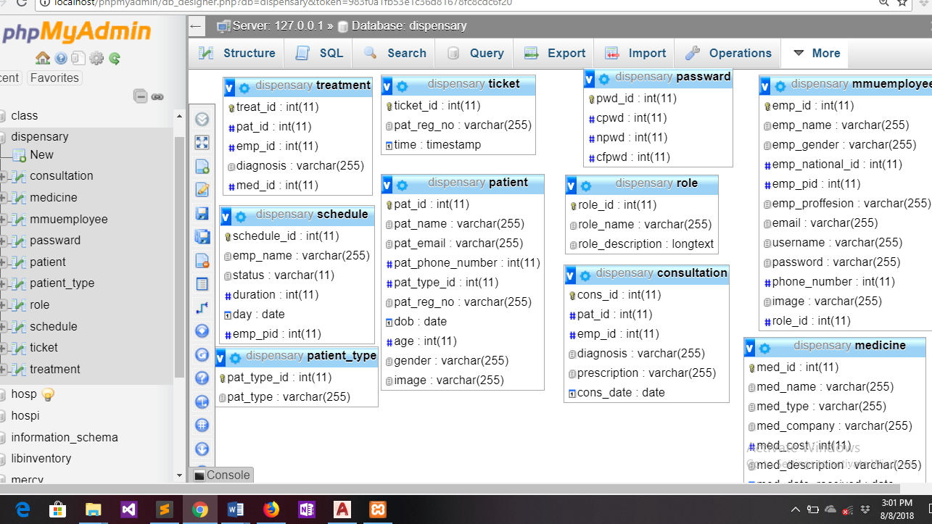

**ER Diagram**

Figure 8: ER Diagram

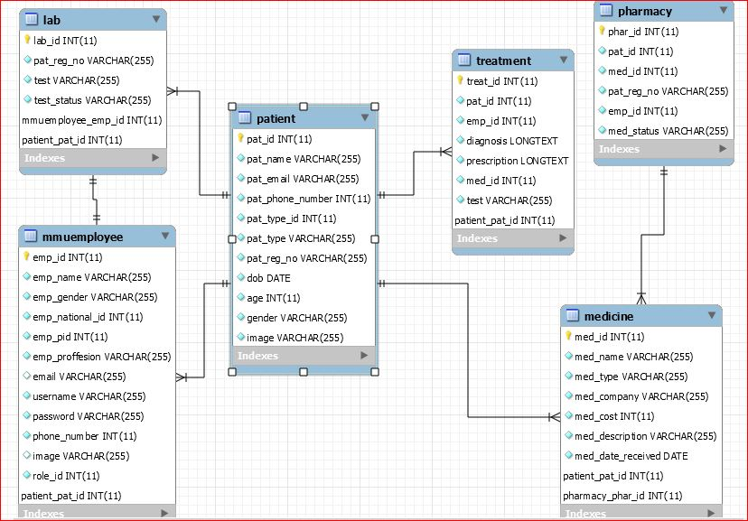

### Database Dictionary

Table 1: Staff Details

|  |  |  |  |
| --- | --- | --- | --- |
| Staff details | | | |
| **Name** | **Type** | **Size** | **Description** |
| ID | Integer |  | Id of the Staff |
| Name | Varchar | 255 | Name of Staff |
| Email | Email |  | Email Staff |
| Professional id | Integer |  | Staff pid |
| Phone number | Integer |  | Staff phone number |
| National id | Integer |  | Staff National id |
| Profession | Varchar | 255 | Staff profession |
| Username | Varchar | 255 | Staff username |
| Gender | Varchar | 255 | Staff gender |
| Image | Varchar | 255 | Staff image |

Table 2:Patient details

|  |  |  |  |
| --- | --- | --- | --- |
| **Name** | **Type** | **Size** | **Description** |
| Name | Varchar | 255 | Patients name |
| Email | Email | 255 | Patient email |
| Patient_reg_no | Varchar | 255 | Patients registration |
| Patient_type | Varchar | 255 | Patients type |
| D.O.B | Date |  | Patients date of birth |
| Age | Integer |  | Patients age |
| Gender | Varchar | 255 | Patients gender |
| Image | Varchar | 255 | Patients profile |

Table 3: Treatment Table

|  |  |  |  |
| --- | --- | --- | --- |
| **Treatment Table** | | | |
| **Name** | **Type** | **Size** | **Description** |
| Pat_id | Integer |  | Patient Id |
| Emp_id | Integer |  | Employee Id |
| Diagnosis | Varchar | 255 | Description of patient diagnosis |
| prescription | Varchar | 255 | Description of patient prescription |
| Med_id | Integer |  | Medical Id |

## 5.3 User interface design

These are the screen short sample of the dispensary interphase.

Figure 9:Patient check-in

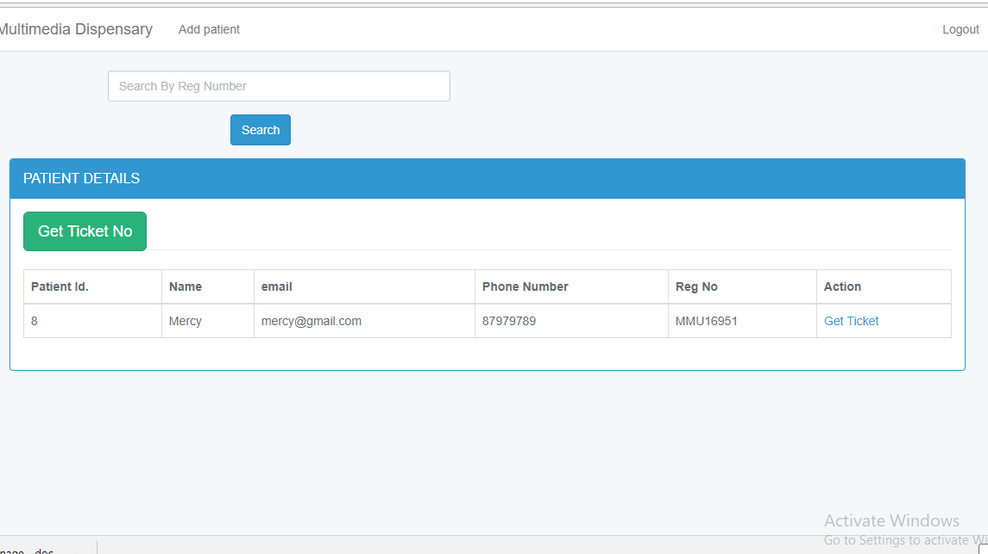

User login

Figure 10: User login

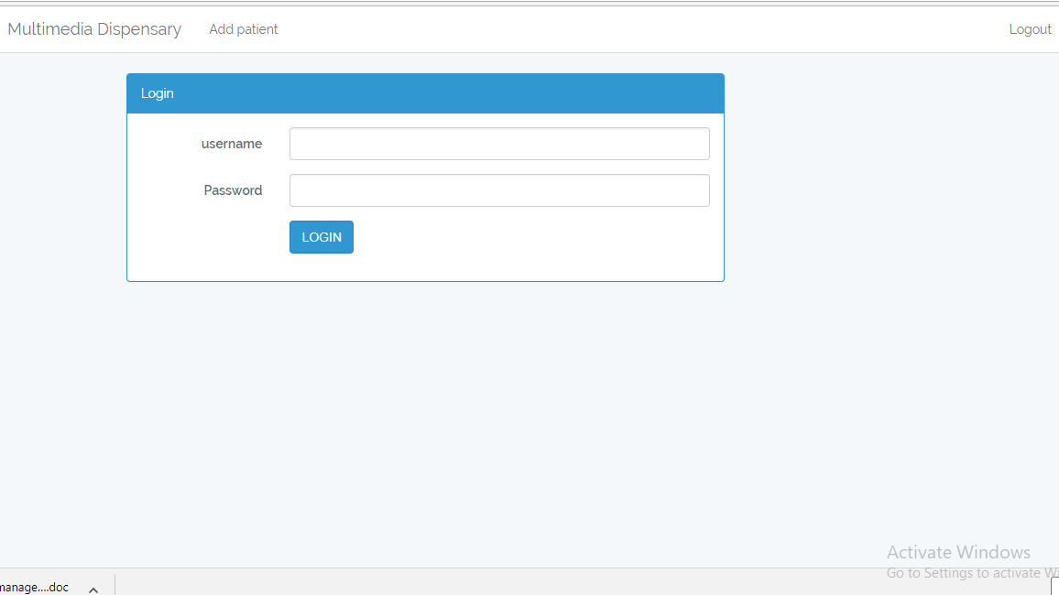

Patient Registration

Figure 11:Patient Registration

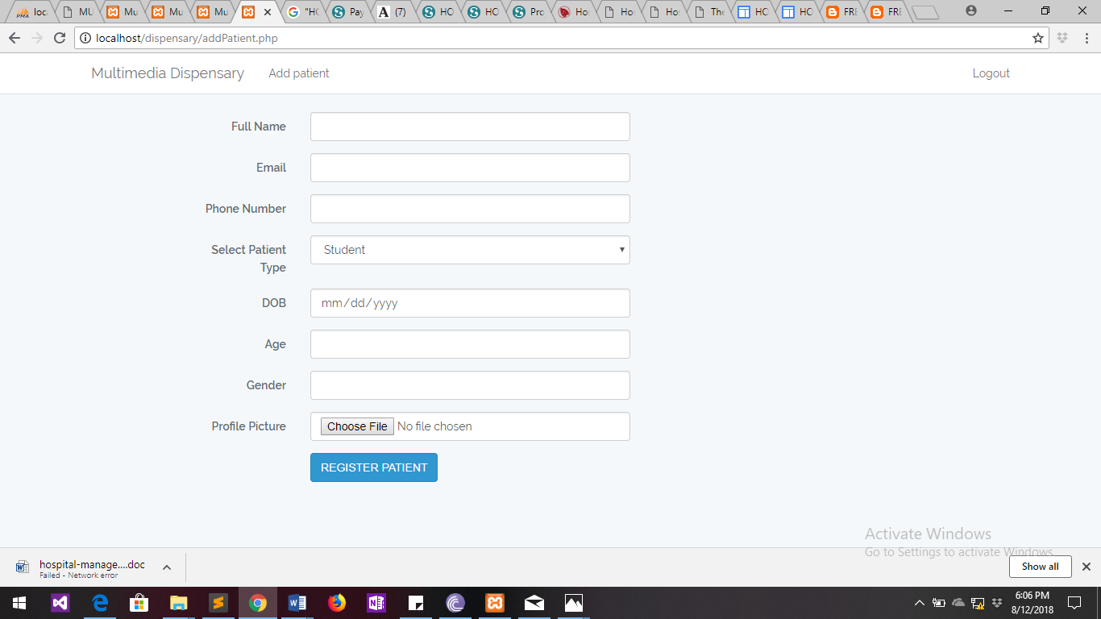

\

# **CHAPTER 6.0 IMPLEMENTING AND TESTING**

## **6.0 Introduction**

This is the stage of the project where the theoretical design is turned into a working system hence it is considered to be the most critical stage in achieving a successful new system and in giving the user, confidence that the new system will work and be effective. It involves careful planning, investigation of the existing system and it’s constraints on implementation, designing of methods to achieve changeover and evaluation of changeover methods.

## **6.1 Development environment**

**HYPERTEXT MARKUP LANGUAGE (HTML):**

This is the standard [markup language](http://en.wikipedia.org/wiki/Markup_language) used to create [web pages](http://en.wikipedia.org/wiki/Web_page).

HTML is written in the form of [HTML elements](http://en.wikipedia.org/wiki/HTML_element) consisting of *tags* enclosed in [angle brackets](http://en.wikipedia.org/wiki/Angle_brackets) (like <html>). HTML tags most commonly come in pairs like <h1> and </h1>, although some tags represent empty elements and so are unpaired, for example <img>. The first tag in a pair is the *start tag*, and the second tag is the end tag (they are also called opening tags and closing tags). Though not always necessary, it is best practice to append a slash to tags which are not paired with a closing tag.

The purpose of a [web browser](http://en.wikipedia.org/wiki/Web_browser) is to read HTML documents and compose them into visible or audible web pages. The browser does not display the HTML tags, but uses the tags to interpret the content of the page. HTML describes the structure of a website [semantically](http://en.wikipedia.org/wiki/Semantic) along with cues for presentation, making it a [markup language](http://en.wikipedia.org/wiki/Markup_language) rather than a [programming language](http://en.wikipedia.org/wiki/Programming_language).

HTML elements form the building blocks of all [websites](http://en.wikipedia.org/wiki/Website). HTML allows [images and objects](http://en.wikipedia.org/wiki/Img_(HTML_element)) to be embedded and can be used to create [interactive forms](http://en.wikipedia.org/wiki/Fieldset). It provides a means to create [structured documents](http://en.wikipedia.org/wiki/Structured_document) by denoting structural [semantics](http://en.wikipedia.org/wiki/Semantic) for text such as headings, paragraphs, lists, [links](http://en.wikipedia.org/wiki/Hyperlink), quotes and other items. It can embed [scripts](http://en.wikipedia.org/wiki/Scripting_language) written in languages such as [JavaScript](http://en.wikipedia.org/wiki/JavaScript) which affect the behavior of HTML web pages.

**CASCADING STYLE SHEETS** (**CSS**):

It is a [style sheet language](http://en.wikipedia.org/wiki/Style_sheet_language) used for describing the [look and formatting](http://en.wikipedia.org/wiki/Presentation_semantics) of a document written in a [markup language](http://en.wikipedia.org/wiki/Markup_language). While most often used to style [web pages](http://en.wikipedia.org/wiki/Web_page) and [interfaces](http://en.wikipedia.org/wiki/Interface_(computing)) written in [HTML](http://en.wikipedia.org/wiki/HTML) and [XHTML](http://en.wikipedia.org/wiki/XHTML), the language can be applied to any kind of [XML](http://en.wikipedia.org/wiki/XML) document, including [plain XML](http://en.wikipedia.org/wiki/Plain_Old_XML), [SVG](http://en.wikipedia.org/wiki/Scalable_Vector_Graphics) and [XUL](http://en.wikipedia.org/wiki/XUL). CSS is a cornerstone specification of [the web](http://en.wikipedia.org/wiki/The_web) and almost all web pages use CSS style sheets to describe their presentation.

CSS is designed primarily to enable the separation of document content from document presentation, including elements such as the [layout](http://en.wikipedia.org/wiki/Page_layout), [colors](http://en.wikipedia.org/wiki/Color), and [fonts](http://en.wikipedia.org/wiki/Typeface).[[1]](http://en.wikipedia.org/wiki/Cascading_Style_Sheets#cite_note-1) This separation can improve content [accessibility](http://en.wikipedia.org/wiki/Accessibility), provide more flexibility and control in the specification of presentation characteristics, enable multiple pages to share formatting, and reduce complexity and repetition in the structural content.

CSS can also allow the same markup page to be presented in different styles for different rendering methods, such as on-screen, in print, by voice (when read out by a speech-based browser or [screen reader](http://en.wikipedia.org/wiki/Screen_reader)) and on [Braille-based](http://en.wikipedia.org/wiki/Braille_display), tactile devices. It can also be used to allow the web page to display differently depending on the screen size or device on which it is being viewed. While the author of a document typically links that document to a CSS file, readers can use a different style sheet, perhaps one on their own computer, to override the one the author has specified. However if the author or the reader did not link the document to a specific style sheet the default style of the browser will be applied.

**MySQL:**

MySQL is developed, distributed, and supported by Oracle Corporation. MySQL is a database system used on the web it runs on a server. MySQL is ideal for both small and large applications. It is very fast, reliable, and easy to use. It supports standard SQL. MySQL can be compiled on a number of platforms. The data in MySQL is stored in tables. A table is a collection of related data, and it consists of columns and rows. Databases are useful when storing information categorically.

FEATURES OF MySQL**:**

1. Internals and portability:
2. Written in C and C++.
3. Tested with a broad range of different compilers.
4. Works on many different platforms.
5. Tested with Purify (a commercial memory leakage detector) as well as with Val grind, a GPL tool.
6. Uses multi-layered server design with independent modules.
7. SECURITY:
8. A privilege and password system that is very flexible and secure, and that enables host-based verification.
9. Password security by encryption of all password traffic when you connect to a server.
10. CONNECTIVITY:

Clients can connect to MySQL Server using several protocols:

Clients can connect using TCP/IP sockets on any platform.

1. LOCALIZATION:
2. The server can provide error messages to clients in many languages.
3. All data is saved in the chosen character set.

Advantages of MySQL:

1. Leading open source RDBMS
2. Ease of use – No frills
3. Fast
4. Robust
5. Security
6. Multiple OS support
7. Free
8. Technical support large database– up to 50 million rows, file size limit up to 8 Million TB

**JAVASCRIPT:**

JavaScript is the scripting language of the Web. All modern HTML pages are using JavaScript. A scripting language is a lightweight programming language. JavaScript code can be inserted into any HTML page, and it can be executed by all types of web browsers. JavaScript is easy to learn.

ADVANTAGES OF JAVASCRIPT:

1. JavaScript is one of the 3 languages all web developers must learn:
2. HTML to define the content of web pages
3. CSS to specify the layout of web pages
4. JavaScript to specify the behavior of web pages

OTHER USES OF JAVASCRIPT:

1. Delete HTML elements
2. Create new HTML elements
3. Copy HTML elements
4. In HTML, JavaScript is a sequence of statements that can be executed by the web browser.

JAVASCRIPT STATEMENTS:

JavaScript statements are "commands" to the browser.

The purpose of the statements is to tell the browser what to do.

JAVASCRIPT CODE:

JavaScript code is a sequence of JavaScript statements.

Each statement is executed by the browser in the sequence they are written.

## JAVASCRIPT FEATURES:

1. Properties are the values associated with a JavaScript object.
2. A JavaScript object is a collection of unordered properties.
3. Properties can usually be changed, added, and deleted, but some are read only.

**PHP (Hypertext Preprocessor)**

PHP is an acronym for "PHP Hypertext Preprocessor". It is widely-used, open source scripting language. The scripts are executed on the server.

CONTENTS OF PHP FILE:

* PHP files can contain text, HTML, CSS, JavaScript, and PHP code
* PHP code are executed on the server, and the result is returned to the browser as plain HTML
* PHP files have extension ".php"

FEATURES OF PHP

1. PHP can generate dynamic page content
2. PHP can create, open, read, write, delete, and close files on the server
3. PHP can collect form data
4. PHP can send and receive cookies
5. PHP can add, delete, modify data in your database
6. PHP can restrict users to access some pages on your website
7. PHP can encrypt data

ADVANTAGES OF PHP

1. PHP runs on various platforms.
2. PHP is compatible with almost all servers used today.
3. PHP supports a wide range of databases
4. PHP is free.

## 6.2 System components

**Patient Registration**

This is meant for patients visiting the Dispensary who are not part of the MULTIMEDIA UNIVERSITY staff or students. Registration of residence is mainly done by the receptionist for new patients.

Staff and Student registration is done by the administrator and stored in the School database during admission of new students and employment of new staff. Patient identification number is automatically generated by the system and does not change as long as the patient is still a member of Multimedia University.

Patient personal information (Full Name, gender, D.O.B, age, address, email, telephone number etc.) These information is captured during registration and stored in the database.

**Check-in**

When a patient visits the dispensary the receptionist checks whether the patient exist in the system or not. If the patient exist in the system the receptionist prints their details and sends the patient information to the Nurse in charge.

**Treatment**

This module entails the treatment a patient receives when visiting the dispensary, the nurse in charge diagnoses the patient then prescribe appropriate medication based on the conclusion of the diagnosis. The nurse then saves the patients details in the system. The salient features of this module are:

1. Patient treatments information.
2. Information of the doctor who gave the prescription or medication.

**Staff Information**

All the staffs that work in the hospital have their information stored in this module. When a new staff is employed in the hospital, all information regarding him/her which include name, date of birth, home address, telephone number, email, professional id are store and could be updated if the information changes. In this module staff identification number is allocated to every person that works in the hospital. The following are the salient feature of this module:

1. Keep record of all staff.
2. The registration of new staff is done here
3. Staff ID is allocated in the module

**Medicine Maintenance**

The administrator manages the medicines in the pharmacy. He add new medications to the system when the University orders medicine by storing the medication information in the system. The medicine will have a unique id for easy follow up. This will give good detailed information of how many medication are in the store to prevent an out of stock situation.

Salient feature:

1. Keeps record of date the medicine: when the drugs were ordered.

## 6.3 Test Plan.

The purpose of testing is to discover errors. Testing is the process of trying to discover every weakness in a project. It provides a way to check the functionality of components and the finished product. It is the process of exercising software with the intention of ensuring that the software system meets its requirements and user expectations and does not fail in an unacceptable manner. There are various types of test. Each test type addresses a specific testing requirement.

**TYPES OF TESTING**:

**Unit testing:**

Unit testing involves the design of test cases that validate that the internal program logic is functioning properly, and that program inputs produce valid outputs.

Table 4: Module Testing

|  |  |  |
| --- | --- | --- |
| **Test Data** | **Test Case** | **Test Result** |
| Module Testing | Edit Record | The system should be able to edit record in the system. |
| Add new Record | The system should be able to add new record to the system. |
| Delete Record | The system should be able to delete record from the system. |
| Search Record | The system should be able to search for the patient’s record. |

**Integration testing:**

Integration tests are designed to test integrated software components to determine if they actually run as one program. Integration testing is specifically aimed at exposing the problems that arise from the combination of components.

Table 5: Integration Testing

|  |  |  |
| --- | --- | --- |
| **Test Data** | **Test Cases** | **Test Result** |
| Integration test | User Authentication | The system should allow valid users to log into the system. |
| Relationship among modules. | The established relationship should work as expected by its users. |

**Acceptance Testing**

Testing the system to determine user acceptance and the readiness of the system.

User Acceptance Testing is a critical phase of any project and requires significant participation by the end user. It also ensures that the system meets the functional requirements.

Table 6: Acceptance Testing

|  |  |  |
| --- | --- | --- |
| **Test Data** | **Test Cases** | **Test Result** |
| Acceptance testing | Interaction of users with the system | The user should be able to use the system with ease. |

# **CHAPTER 7.0 CONCLUSION**

## **7.1 Achievements and lessons learnt**

The major achievement of this project is the ability to register new students, staff and residence and store it in the database. The requirements takes care of all the requirements of the Multimedia University and is capable of providing easy and effective storage of information related to patients who visit the dispensary.

This project has been a rewarding experience in my course work since have gained knowledge by gaining insight of the working of the hospital. The understanding of the database design has greatly improved because in order to generate in order to generate the final report the database design has to be greatly followed.

## **7.2 CONCLUSION.**

Inputting patient’s information electronically into the system will ensure data is secured from damage and access by unauthorized users. Using this application it is easy to retrieve patient’s data hence fast processing of information which guarantee accurate maintenance of patient’s details. The system reduces the human effort and increases accuracy of speed.

## **7.3 Recommendations**

Improvement to be made on the system to enable the administrator track the drug inventory for easy management of the drugs in the pharmacy.

The development of the system to be continued by like-minded persons who live to see the dream I had and build effective system that can be used to cut cost of manual labor and enable efficiency of service provision.

Hosting of backup up information in the cloud incase the system fails.

## **References**

Mullins, C. 2002. Database Administration Published by Pearson Education Corporate Sales Division, ISBN: 0-201-74129-6 Quoted: 15.12.2011.

H. M. Gibson, "National health care expenditures, 1979." *Health Care Financing Rev.,* 2:1-36, 1980.

Vieira, R. (2007). SQL Server 2005 Programming, Professional, ISBN:0-7645-8434-0 Quoted: 15.12.2007.

Kasser, J. (2002). *The cataract methodology for systems and software acquisition* (Doctoral dissertation, Systems Engineering Society of Australia and ITEA Southern Cross Chapter)

Shen, W., & Liu, S. (2003, November). Formalization, testing and execution of a use case diagram. In *International Conference on Formal Engineering Methods* (pp. 68-85). Springer, Berlin, Heidelberg.

## **Appendices**

## **Appendix I: User manual**

## **Appendix II Data collections tools**

**QUESTIONNAIRES FOR HOSPITAL STAFF:**

Instructions: Answer as specified by the format. Put NA for non-application situation.

1. What are your expectations out of the new system (computerized)? Rate the following on a scale of 1-4 giving allow value for low priority.
2. better cataloguing
3. better managing of users
4. better account and patients management
5. computer awareness
6. any other________________
7. Is there any difference in the access privileges for Dispensary staff?

Yes/No

________________________________________________________________________________________________

if Yes Please specify how you want users to be categorized?

_______________________or

_______________________

1. Do you have data of patients entered into some kind of database?

Yes/No

1. Would you like online registration for users rather than the printed form?

Yes/No

1. Do you already have some existing categorization of patients on the basis as specified in question 4 above?

Yes/No

1. Any other specific suggestion/expectation out of the proposed system. If yes, please specify

____________________________________________________________________________________________________

# 

# **Appendix III:** GANT CHART

Table 7: Project schedule

|  |  |  |  |  |  |  |  |  |  |  |  |  |  |
| --- | --- | --- | --- | --- | --- | --- | --- | --- | --- | --- | --- | --- | --- |
| **DURATION** | **May**  **2018** | | | | **June**  **2018** | | | | **July**  **2018** | | | | **August**  **2018** |
| **ACTIVITY** | **WEEKS** | | | | WEEKS | | | | WEEKS | | | | WEEKS |
| FEASIBILTY STUDY |  |  |  |  |  |  |  |  |  |  |  |  |  |
| DESIGN |  |  |  |  |  |  |  |  |  |  |  |  |  |
| CODING |  |  |  |  |  |  |  |  |  |  |  |  |  |
| TESTING |  |  |  |  |  |  |  |  |  |  |  |  |  |
| IMPLEMENTATION |  |  |  |  |  |  |  |  |  |  |  |  |  |
| DOCUMENTATION |  |  |  |  |  |  |  |  |  |  |  |  |  |
| PRESENTATION |  |  |  |  |  |  |  |  |  |  |  |  |  |

## **Appendix I**V: Project budget

Table 8:Project budget

|  |  |  |
| --- | --- | --- |
| **Resource** | **Location** | **Amount(Ksh)** |
| Research resources | data bundles | 300.00 |
| Printing Project documentation and binding | MMU Printing Press | 600.00 |
| CD-ROM |  | 50.00 |
| Flash disk |  | 800.00 |

**Appendix** V Sample code for deleting patient

<?php

//including the database connection file

include_once("classes/Constant.php");

$patientId = $_GET['patientId'];

$patien=$con->connection->query("DELETE FROM patient WHERE pat_id='$patientId'");

if ($patien) {

header("Location:viewDetails.php");}

$employeeId = $_GET['employeeId'];

$employee=$con->connection->query("DELETE FROM mmuemployee WHERE emp_id='$employeeId'");

if ($patien) {

header("Location:viewDetails.php");}?>

<?php include 'footer.php';

?>